Little Houghton Parish Council (LHPC) Meeting 8

Date: |  | 15/08/23
Venue: |  | Houghton Main Sports and Social Club
Time: |  | 6.00pm
Attendees: |  | Jeff Greasley, Colin Ward, Amanda McGrath, Hilary Cook, Cheryl Hanson  Jean Ironmonger, Kevin Osborne
Apologies: |  | Katie Colbeck
No: | Agenda Item |  | Discussed | Actions
1 | Minutes of committee meeting held on: |  | Agreed Jeff  Seconded Colin
2 | Matters arising |  | Ref speed limit Middlecliff Lane – Kevin Osborne received a reply 18th July 23  from Harriert Parkin  - The entire length is 30m/hr unless sign is shown then 30  Suggested sign – slow down children playing  Drains Little Houghton – Kevin Osborne received a reply from Oliver,@ Drainage and Transport  - work is planned to cleanse all the gullies on Middlecliff Lane. No date set.  Defib – Jeff has applied for one but still waiting to hear from the Government | Clerk to look in to
3 | Banking Finances
 | 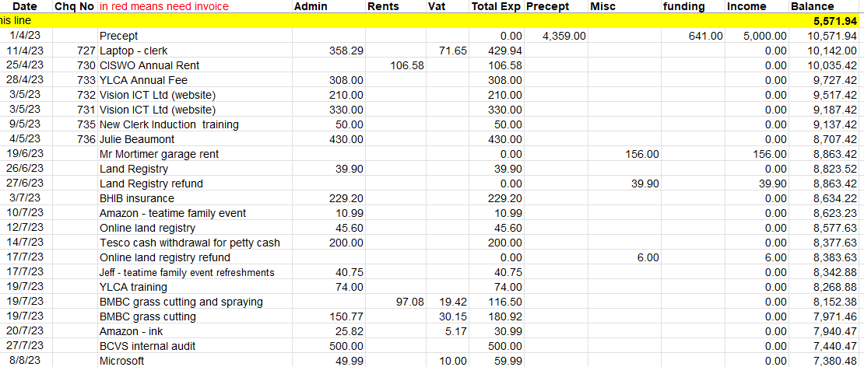
4 | Funding |  | Still awaiting bids so can apply for funding. Awaiting responses from companies re the playground.
5 | Parish Council Clerk post |  | Post now filled – Katie Colbeck is in place
6 | Correspondence |  | HMRC – PAYE  Form from YLCA consent forms to send us emails directly
7 | AoB |  | Golf ball nearly hit Amanda‘s dog on Chapel Lane. She went to see Anthony at the driving range he said it happens all the time and said there was nothing they could do about it.  There are many golf balls on the lane so it does happen regularly, but families walk up and down that lane so people and children are at risk.  Issue finding old records – box file gone to a department at the council.  Jeff visited Caroline’s daughter regarding missing files, however she is distressed that still getting letters from BMBC and the insurance  Precept – needs to be for Nov ready for next year. We pay out £5,003.20 each year and only get £5,000  Parish Councillors, Jean, Connor, Katie and children lane cleared for people to park. Tidy Team came and were really helpful.  Still waiting for council to quote for clearing of 2 diseased trees in parish field  Quotes have been obtained by Hilary | Clerk to send a formal letter re concerns.  Amanda to contact Peter Clark at BMBC  Jeff to liaise with council to remove Caroline’s address  Amanda to liaise with other companies to ensure address removed.  Colin will send Clerk email for Tidy Team so we can formally thank them
9 | Next meeting |  | All future meetings will be on the 2nd Tuesday of alternate months:  October, December, February, April, June, August  Next meeting is on:  Tuesday 10th October 2023  at Houghton Main Sports and Social Club  at 6pm

